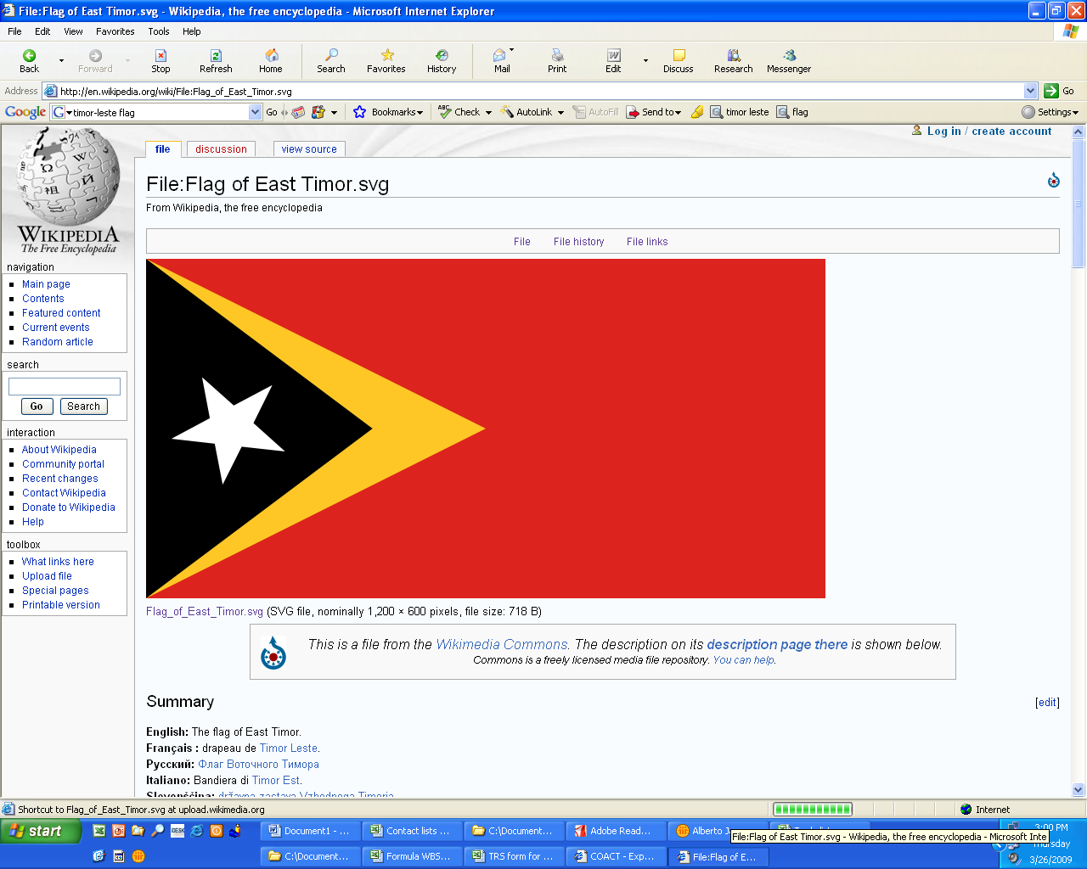
Improving the Business Environment Through
Constructive Dialogue in Timor-Leste

Better Business Initiative
Inisiativa Negosios Diak Liu

AN INITIATIVE FACILITATED BY THE INTERNATIONAL FINANCE CORPORATION (IFC) IN COLLABORATION WITH THE MINISTRY OF ECONOMY AND DEVELOPMENT (MED)
OF THE GOVERNMENT OF TIMOR-LESTE

OVERVIEW

Background: The Timor-Leste Better Business Initiative was established in January 2008 between the International Finance Corporation and the Ministry of Economy and Development to improve the business enabling environment by providing a platform for effective and constructive dialogue between the business community and the government of Timor-Leste. It is also intended to facilitate information-sharing with potential investors.

The Better Business Initiative (BBI) draws on IFC’s successes with similar efforts in other countries, notably the Vietnam Business Forum, the Cambodia Government-Private Sector Forum and the Lao PDR Business Forum.

IFC serves as the Secretariat for the dialogue, assisting the public-private BBI in Timor-Leste. In this role, IFC collaborates with the Ministry of Economy and Development, which is the Government’s coordinator for the BBI, as well as the various associations representing the business community and individual business representatives.

Objectives: The objectives of the Better Business Initiative are to:
- Facilitate dialogue between the government of Timor-Leste and the private sector, which includes the broadest private sector participation possible, including the districts;
- Assist the Timor-Leste government in developing the private sector;
- Remove the barriers that businesses face with regard to entry, exit, access to credit and other priorities determined by the private sector;
- Promote consistent enforcement and non-discretionary interpretation of laws and regulations;
- Provide feedback on various government policies affecting the private sector;
- Provide feedback on draft government laws and regulations that could affect the private sector.

Operations: The Better Business Initiative is a formal dialogue mechanism between the government and the private sector, both foreign and domestic. The BBI also helps strengthen the role and voice of the private sector in Timor-Leste. The dialogue’s effectiveness stems fundamentally from a solid partnership and direct linkage between four main parties: the domestic and foreign private sector, the Timor-Leste government, donor partners, and multilateral institutions.

Role of the Better Business Initiative: The BBI promotes policy dialogue among these four key stakeholders in order to develop a successful environment for private enterprise. All issues raised in the BBI are of interest to a significant number of private sector enterprises operating in Timor-Leste, rather than just a few individual companies.

BBI structure and processes: The BBI works through two primary structures: working groups and a forum chaired by the Government of Timor-Leste. IFC acts as the Secretariat for the BBI and is responsible for overall coordination and facilitation.

Forum: The Timor-Leste Better Business Initiative Forum has not yet taken place. It is to be chaired by the Prime Minister and the Minister of Economy and Development and was expected to take place biannually but the Government has not agreed to a forum driven by anyone other than themselves. They have, however, requested that the BBI facilitate private sector participation in the Prime Minister’s consultation (March and July 2009). The first of these consultations was an opportunity for the Working Groups listed below to inform top-level government officials about what they have achieved in their regular meetings and to identify priorities and issues that remain unresolved.

Working Groups: Two Working Groups have been established under the BBI to date:
- Administrative Barriers Working Group
- Access to Financial Services

It is envisaged that additional Working Groups will be formed as per the interests and needs of the business community, e.g. on Tourism, and potential subgroups to address very specific issues.

Meetings of the respective Working Groups take place as often as necessary and are driven by actions needing to be taken.

The first meeting, called the Private Sector Working Group (PSWG) meeting, is a meeting for private sector members of the WG and representatives of the companies that are interested in participating. These meetings serve to reach agreement on which issues will be forwarded to the Working Groups (WGs), which will be under participation of the public side.

Composition and role of the Private Sector Working Groups: The PSWGs include representatives from the private sector, representatives of business associations, and all persons working in legally operating private enterprises in Timor-Leste that wish to attend.

Each PSWG selects approximately five to ten people to represent its interests in the respective WG, as well as one representative to co-chair the WG. PSWG members meet prior to the formal WG meeting to review the progress of the previous BBI Forum and WG meetings, produce position papers on issues of concern, discuss new issues, and recommend an agenda for the formal WG meeting. The BBI Secretariat then forwards the agenda to the Ministry of Economy and Development for consideration and then the Secretariat circulates the information to respective government parties.

Role of the BBI Secretariat: IFC acts as the Secretariat for the BBI. Its purpose is to facilitate the constructive dialogue between the government and the business community, both foreign and domestic. The BBI Secretariat ensures that initiatives and issues emanating from the private sector are appropriately identified, are broadly representative, are adequately researched and are presented to the Government through the WGs in a focused, solutions-oriented manner. The Secretariat will coordinates its overall activities without the expected support form a Coordinating Unit in the Ministry of Economy and Development but is focused on this challenge. It also: maintains a database of active participants in the Forum; facilitates the discussions of PSWGs and the WGs; liaises with the Timor-Leste Government when requested; assists in the compilation and distribution of issues papers and other technical documents; solicits comments from WGs on draft laws and regulations; arranges technical assistance on a selective basis, where required to resolve or shed light on particular issues, through the IFC managed Research Fund; and generally enhances BBI activities by facilitating the participation of the domestic and foreign business communities.

The BBI Secretariat also arranges meetings between the Government and the WGs. Where appropriate, the Secretariat assists both the Government and the private sector to analyze issues constraining growth and to make recommendations based on best practices in the region and elsewhere. Finally, the Secretariat monitors discussion of issues raised, implementation of potential solutions and disseminate information to the WGs and the broader community of businesses, multilateral institutions and donors.

Donor Participation: Donor agencies are involved mainly through subgroup meetings and will be invited to attend the BBI Forum and observe other BBI activities in order to promote an effective link between policy recommendations for private sector development and the donors whose projects support private sector development. The BBI Secretariat channels specific issues that may require technical assistance, from the WGs to donors, usually starting with the IFC, toward sustained follow up on reform initiatives or pilot activities toward deeper engagement. A recent example of this is in response to Financial Services working group priority, increased access to SME credit, the BBI facilitated a Pilot Guarantee Fund for credit for agricultural commodity traders in the border regions of Timor-Leste. The German Aid Agency (GTZ) provides a guarantee to the Australia and New Zealand Bank (ANZ) and all lending and outreach executed on commercial terms by the Bank. The BBI provided technical and logistical support to facilitate the deal. If the Fund is successful it is a powerful argument for IFC or other commercially oriented donors to scale up activities.

Challenges: The foremost challenge posed by recent security crises seems to be effectively addressed by the current Government. Entrenched challenges remain, including:
- Weak institutions and capacity on public and private sides: every step is labor intensive.
- No mechanisms within GoTL or private sector for follow up on initiatives: must create them for each reform/process.
- Very crowded and uncoordinated donor field: bad advice easy to find and dialogue remains an unproven method for change.
- Legacy of Indonesian occupation: poor education, limited management experience, weak financial management, but high expectations.
- Private sector looks to government for solutions.
- IFC systems not set up for the scale and labor intensity solutions in Timor-Leste seem to require.

The BBI is beginning to make progress in a difficult environment remaining flexible, responsive to private sector priorities and opportunities to support reform.

For further information, please contact:

Milissa Day, mday@ifc.org (670) 728 3213
Bernardo dos Reis, bdosreis@ifc.org (670) 725 4512

